Join the fitness revelation at Benchmark Fitness Today!
6 week taster program
  - All fitness levels welcome
  - Convenient location – Slough Hockey Club
  - Variety is key: different work outs every day
  - Boxing-weight sessions-barbells dumbells-slam balls-plyo boxes-battle ropes, boxing, HIT and circuit training and much more
  - Quick and effective – 30 min sessions
- Achieve your fitness and body goals!
- Weight loss
- Increase strength
- Boost energy



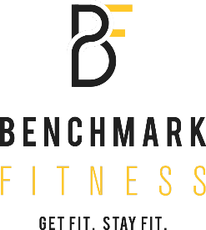
- 6 week objective given
- Body fat % Visceral fat % Muscle % Water %
- Metabolic Age all measured
- INVEST IN YOUR HEALTH NOW
All of the above for £50

